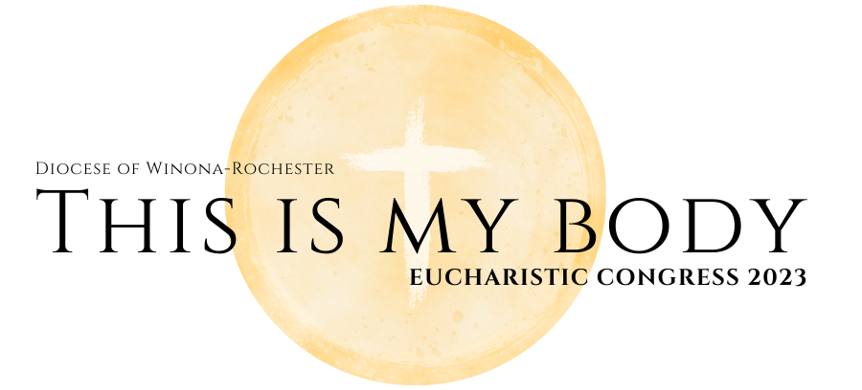
REGISTRATION FORM
- June 10, 2023, Mankato Civic Center
- 8:00 AM Check In, 9:00 AM events begin, Conclude 5:30 & 5:45 pm
- Early Registration $35 adult, $15 children 8-17, 0-7 free.
- Registration after 5/16/23 is $40 adult & $20 children 5-17, 0-7 free

Name

e-mail Phone

Address

City and State Zip

Parish Phone

Optional Box Lunch Choices: (child box lunch is for ages 2-12).
- Meat Sandwich, chips, cookie & 20oz bottle of water ($15.00 adult, $10 child)
- Vegetarian Sandwich, chips, cookie & 20oz bottle of water ($15.00, $10 child)

Congress Registration Payment

___ # of Adults ($35, $40 after March 31, 2023) _____________
___ # of Children ($10, $20 after March 31, 2023) _____________
Total Cost _____________
Box Lunch Payment
___ # of Adults ($15) _____________
___ # of Children ($10) _____________
Total Cost _____________

- Please make your check out to St. Theodore Catholic Church and attach it to your registration form. Please turn into the parish office on or before May 15, 2023 to get the discounted rate. Registration after May 15th must be submitted to the parish office by June 1st, 2023 with the increased registration amounts.

- Free bus rid to Congress is available as a first come first serve basis for those registered. Contact parish office to reserve your seat(s)!

